Understanding Japanese American Incarceration with Documents
By Christopher Martell, Ed.D.
University of Massachusetts Boston

Instructions for Teachers

The study of history is about understanding interpretation of the past. There are various methods for helping students to do this. Some methods can empower students to be the “creators” of history, rather than simply the “consumers” of other peoples’ interpretations. However, having students interpret the past can sometime leave them with the impression that all events are debatable. Yet, not all historical events are constructively debatable. For example, teachers should never ask students to debate topics that question peoples’ humanity. We should never ask students to justify slavery, the Holocaust, or the Rwandan Genocide. Worse, if we did portray these events as debatable, some students who have these painful events in their family’s histories will have to face classmates arguing that these tragic events were justified, which would do them harm.

To illustrate this, think about doing an inquiry on the Japanese American incarceration (which is the term now widely used among Japanese Americans for what some have called internment; see here: www.densho.org/terminology) that asks the following question: “Was Japanese American internment justified?” Now imagine what possible debates that can unfurl in your classroom. Finally, assume that there is at least one Japanese American student with grandparents or great grandparents who were imprisoned during World War II simply because their ancestors came from Japan.

A better question would not ask the students to debate if it should have happened, but instead why it happened. How could the U.S. government come to the conclusion that 120,000 men, women, and children (2/3rd of whom were U.S. citizens) should be sent to prison camps? Was it due to racism? Was it due to unsubstantiated and irrational war fears of internal sabotage? Was it a result of economic competition related to Japanese American owned businesses and farms? Was it due to the group’s size (less than 1% of the national population). This is a much more important historical question. For some events asking if it was justified is appropriate, for other events it is not.

Yet, those questions still mainly center white people in the narrative of Japanese American incarceration. The best question would instead center Japanese Americans’ experiences and perspectives themselves. Today, the Japanese American community asks questions like: How did Japanese Americans resist their incarceration? How did they sustain their community and cultures while in camp? How did they organize during the redress movement in the 1970s and 80s?

Document-Based Activity

Using the following documents, we will investigate this question: How should we remember what the U.S. government did to Japanese Americans during World War II?

In answering that question, consider these sub-questions: How did Japanese Americans resist their incarceration? How did they sustain their community and cultures while in camp? How did they organize during the redress movement in the 1970s and 80s?

Document A: Timeline of the Japanese American Community

1869 - First documented group of Japanese immigrants arrive on the mainland U.S. (Gold Hills, California) to work as agricultural laborers.

1885 - First major wave of Japanese immigrants arrives to provide labor in California fruit and produce farms.

1906 - The San Francisco Board of Education passes a resolution to segregate children of Chinese, Japanese, and Korean ancestry.

1913 - California passes the Alien Land Law, forbidding "all aliens ineligible for citizenship," from owning land (Asian Americans were excluded from citizenship through a series of laws, including the Chinese Exclusion Act). (More here: https://encyclopedia.densho.org/Alien%20land%20laws)

1924 - Congress passes the Immigration Act of 1924 effectively ending all Japanese immigration to the U.S.

November 1941 - Munson Report released (Document E). (More here: https://encyclopedia.densho.org/Munson%20Report)

December 7, 1941 – The Empire of Japan bombs U.S. ships and planes at the Pearl Harbor military base in Hawaii.

February 19, 1942 - President Roosevelt signs Executive Order 9066 authorizing military authorities to exclude civilians from any area without trial or hearing (Document H). (More here: https://encyclopedia.densho.org/Executive%20Order%209066)

January 1943 - The War Department announces the formation of a segregated unit of Japanese American soldiers. (More here: https://encyclopedia.densho.org/442nd%20Regimental%20Combat%20Team)

Late winter 1943 – Every Japanese American incarceree was required to complete a government questionnaire misleadingly entitled "Application for Leave Clearance" to distinguish whether they were "loyal" or "disloyal." Question #27 asked if men were willing to serve on combat duty. Question #28 asked if individuals would swear unqualified allegiance to the United States and forswear any form of allegiance to the Emperor of Japan. Both questions caused a great deal of concern and unrest. Citizens resented being asked to renounce loyalty to the Emperor of Japan when they had never held a loyalty to the Emperor. Japanese immigrants were barred from becoming U.S. citizens on the basis of race, so renouncing their only citizenship would be problematic, leaving them stateless. Some men worried that declaring their willingness to serve in combat units of the army would be akin to volunteering. (More here: https://encyclopedia.densho.org/Loyalty_questionnaire/)

January 1944 - The War Department imposes the draft on Japanese American men, including those incarcerated in the camps.

December 1944 - The Supreme Court upholds the constitutionality of Executive Order 9066 in Korematsu v. United States (Document J). (More here: https://encyclopedia.densho.org/Korematsu%20v.%20United%20States)

March 20, 1946 - Tule Lake "Segregation Center" closes. This is the last War Relocation Authority facility to close.

1980 - The Commission on Wartime Relocation and Internment of Civilians is established.

1983 - The Commission on Wartime Relocation and Internment of Civilians issues its report, Personal Justice Denied. (More here: https://encyclopedia.densho.org/Commission%20on%20Wartime%20Relocation%20and%20Internment%20of%20Civilians)

August 10, 1988 - President Ronald Reagan signs HR 442 into law. It acknowledges that the incarceration of more than 110,000 individuals of Japanese descent was unjust, and offers an apology and reparation payments of $20,000 to each person incarcerated.

Document B: U.S. Census Data (1940)

Total Americans: 131,669,275

White Americans: 118,214,870 (including 1,858,024 Latino/as)
Black Americans: 12,865,518
Native/Indigenous People: 333,969
Asian Americans: 254,918 (including 126,947 Japanese Americans)

NOTE: Historical estimates from 1940 place German Americans around 30% of the population or 39 million people and Italian Americans around 6% or 8 million people. Latino/as were included in the White American population on the Census.

Document C: The Munson Report (1941)
There is no Japanese “problem” on the Coast. There will be no armed uprising of Japanese. There will undoubtedly be some sabotage financed by Japan and executed largely by imported agents... In each Naval District there are about 250 to 300 suspects under surveillance. It is easy to get on the suspect list, merely a speech in favor of Japan at some banquet being sufficient to land one there. The Intelligence Services are generous with the title of suspect and are taking no chances. Privately, they believe that only 50 or 60 in each district can be classed as really dangerous. The Japanese are hampered as saboteurs because of their easily recognized physical appearance. It will be hard for them to get near anything to blow up if it is guarded. There is far more danger from Communists and people of the Bridges type on the Coast than there is from Japanese. The Japanese here is almost exclusively a farmer, a fisherman or a small businessman. He has no entree to plants or intricate machinery.

Source: In 1941 President Roosevelt ordered the State Department to investigate the loyalty of Japanese Americans. Curtis B. Munson carried out the investigation.

Document D: Oakland, California. Tatsuro Masuda posts his grocery store on the day after Pearl Harbor.
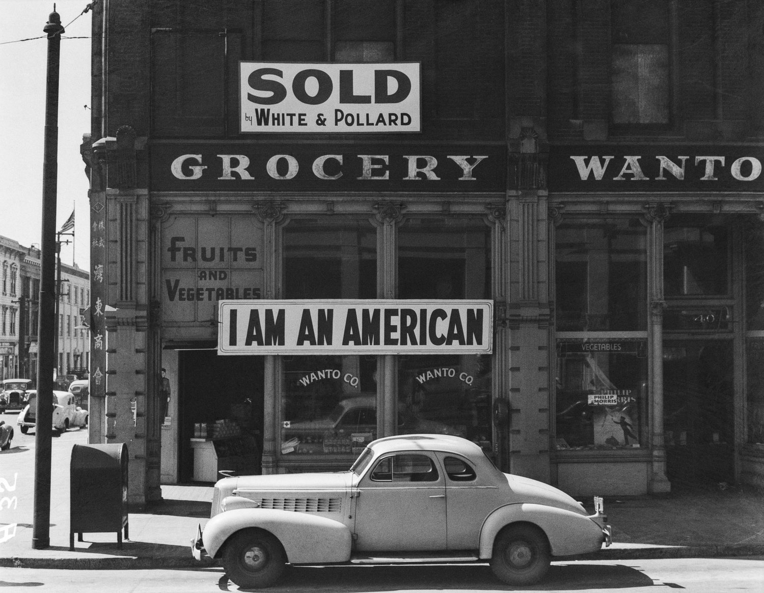

Document E: Liberty Café, South Boston (Circa 1942)
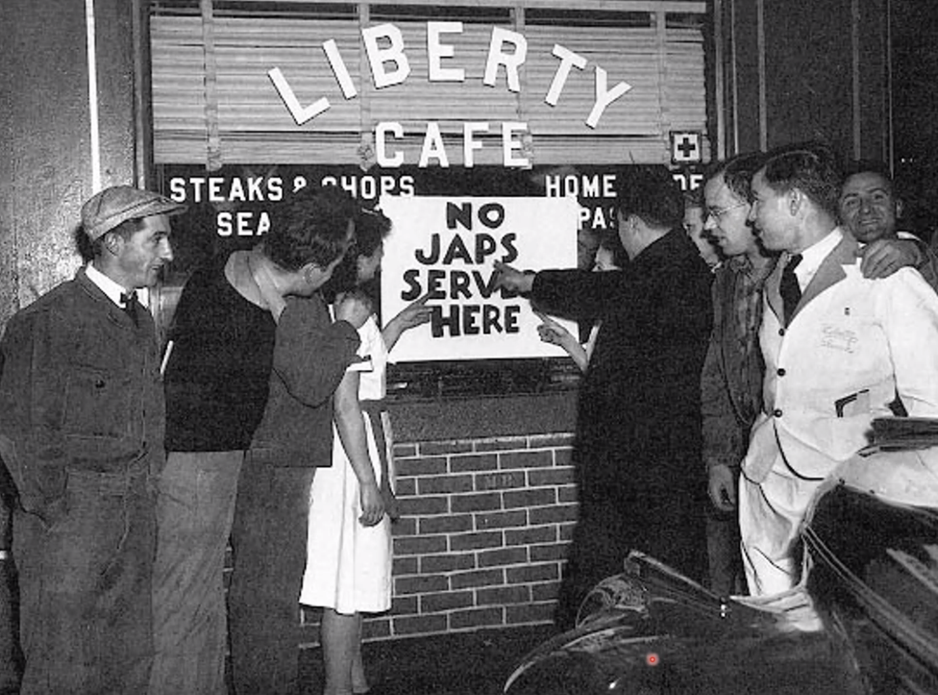

Document F: Statement by California Attorney General Earl Warren (1942)
At a conference of sheriffs and district attorneys on February 2, 1942, California Attorney General Earl Warren (and candidate for Governor) made the following statement:

It seems to me that it is quite significant that in this great state of ours we have had no fifth column activities and no sabotage reported. It looks very much to me as though it is a studied effort not to have any until the zero hour arrives. There will be a great event of sabotage to come.

Later he testified in March 1942 before the Tolan Committee that was assembled by the U.S. House of Representatives and held hearings in four cities on the possible removal of Japanese Americans from the West Coast:

Well, my God! We have thousands and thousands of Japanese here. We could have an invasion here… I will admit, however, that I believe there is a great danger today from the Japanese population, and particularly from those Japanese who, although born here, have received a liberal amount of their education in Japan. Still, I cannot bring myself to believe the entire Japanese population is disloyal to this country… When we are dealing with the Caucasian race, we have methods that will test the loyalty of them; and we believe we can, in dealing with the Germans and Italians, arrive at some fairly sounds conclusions… when we deal with the Japanese, we are in an entirely different field and we cannot form any opinion… The Japanese situation as it exists in this state today may well be the Achilles' heel of the entire civilian defense effort.

Source: Sandhya, Ramadas (2009). How Earl Warren previewed today’s civil liberties debate – And got it right in the end. Asian American Legal Journal, 16, 73-130.
Document G: Tolan Committee Testimony by Attorney Clarence E. Rust (1942)

I find no popular demand for the efforts to drive the so-called alien enemies from California. The clamor seems to come from chambers of commerce, Associated Farmers, and the newspapers notorious as spokesmen for reactionary interests. In view of this fact, effort should be made to determine whether there is any connection between the clamor for the dispossession of the Japanese farmers and the desire of these clamoring interests to get possession of the Japanese farms and the elimination of the Japanese competition. One half of employed Japanese-Americans on the West Coast were in agriculture. They were the largest group of farmers in California's fruit and vegetable markets; agricultural experts expected thirty-five percent of California's 1942 truck crops to come from Japanese-Americans. Japanese-American farms in 1940 were worth $72 million plus $6 million in equipment. Per acre their farms were worth $279.96, in contrast to the average value of $37.94 for all California farms. The Grower-Shipper Vegetable Association was quoted in a local paper, "If all the Japs were removed tomorrow, we'd never miss them in two weeks, because the white farmers can take over and produce everything the Jap grows. And we don't want them back when the war ends, either."

Source: From Richard L. Miller (2001). Confiscations from Japanese-Americans during World War II.

Document H: Executive Order No. 9066 (1942)

Executive Order No. 9066
The President
Executive Order
Authorizing the Secretary of War to Prescribe Military Areas

Whereas the successful prosecution of the war requires every possible protection against espionage and against sabotage to national-defense material, national-defense premises, and national-defense utilities… Now, therefore, by virtue of the authority vested in me as President of the United States, and Commander in Chief of the Army and Navy, I hereby authorize and direct the Secretary of War, and the Military Commanders whom he may from time to time designate, whenever he or any designated Commander deems such action necessary or desirable, to prescribe military areas in such places and of such extent as he or the appropriate Military Commander may determine, from which any or all persons may be excluded, and with respect to which, the right of any person to enter, remain in, or leave shall be subject to whatever restrictions the Secretary of War or the appropriate Military Commander may impose in his discretion. The Secretary of War is hereby authorized to provide for residents of any such area who are excluded therefrom, such transportation, food, shelter, and other accommodations as may be necessary, in the judgment of the Secretary of War or the said Military Commander, and until other arrangements are made, to accomplish the purpose of this order… Franklin D. Roosevelt, The White House, February 19, 1942.

This order gave the military broad powers to ban any citizen from a fifty- to sixty-mile-wide coastal area stretching from Washington state to California and extending inland into southern Arizona. The order also authorized transporting these citizens to assembly centers hastily set up and governed by the military in California, Arizona, Washington state, and Oregon. The same executive order was also applied to smaller numbers of residents of the United States who were of Italian or German descent. More than 300 Italian and 5,000 German residents (mostly resident aliens and naturalized citizens) from across the country were interned. Yet, the wartime measures applied to Japanese Americans were more sweeping, uprooting entire communities and targeting native-born citizens, naturalized citizens, and resident aliens.

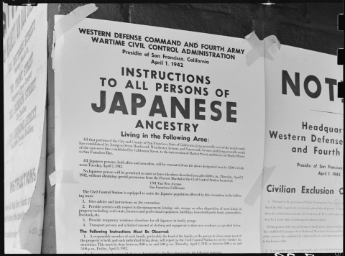

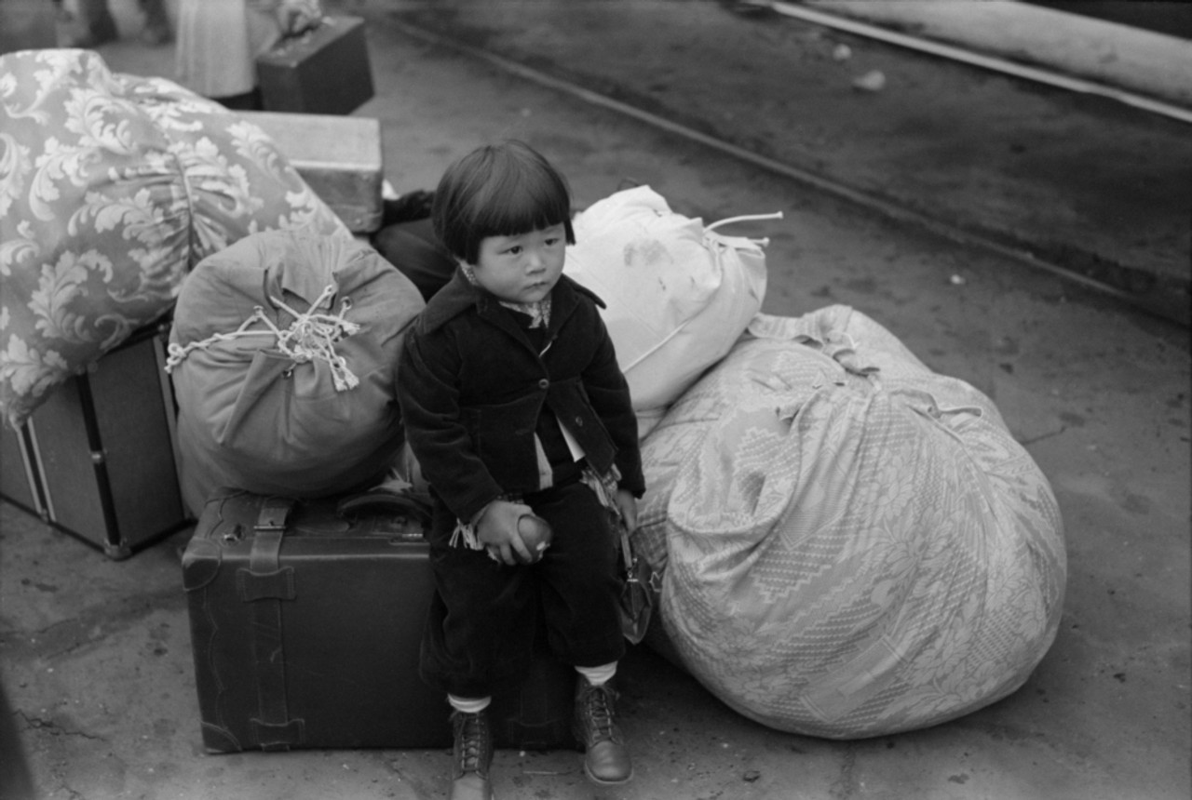
Document I: Tanforan Assembly Center (1942)
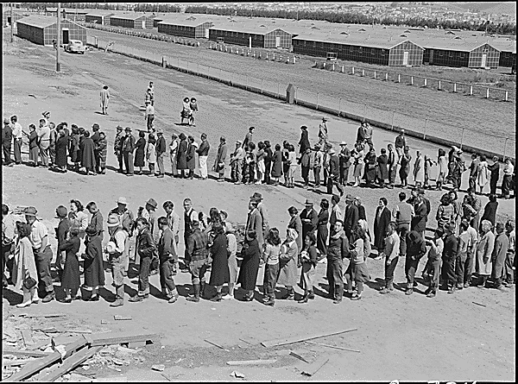
Incarcerated Japanese Americans in line for the mess hall. Tanforan, a horse racetrack, and other temporary prison camps were used to shelter people (sometimes in horse stalls) while they waited for permanent camps to be built.

Document J: Excerpt from Harry Paxton Howard’s “Americans in Concentration Camps” Published in The Crisis (1942)

Along the eastern coast of the United States, where the numbers of Americans of Japanese ancestry is comparatively small, no concentration camps have been established. From a military point of view, the only danger on this coast is from Germany and Italy... But the American government has not taken any such high-handed action against Germans and Italians – and their American-born descendants – on the East Coast, as has been taken against Japanese and their American-born descendants on the West Coast. Germans and Italians are “white.” Color seems to be the only possible reason why thousands of American citizens of Japanese ancestry are in concentration camps. Anyway, there are no Italian-American, or German-American citizens in such camps.

Source: Harry Paxton Howard, “Americans in Concentration Camps,” The Crisis, September, 1942. Founded in 1910 by W.E.B. Du Bois, The Crisis is one of the oldest Black periodicals in the United States and is dedicated to promoting civil rights.

Document K: Letter from Gordon Hirabayashi Refusing Incarceration (1942)
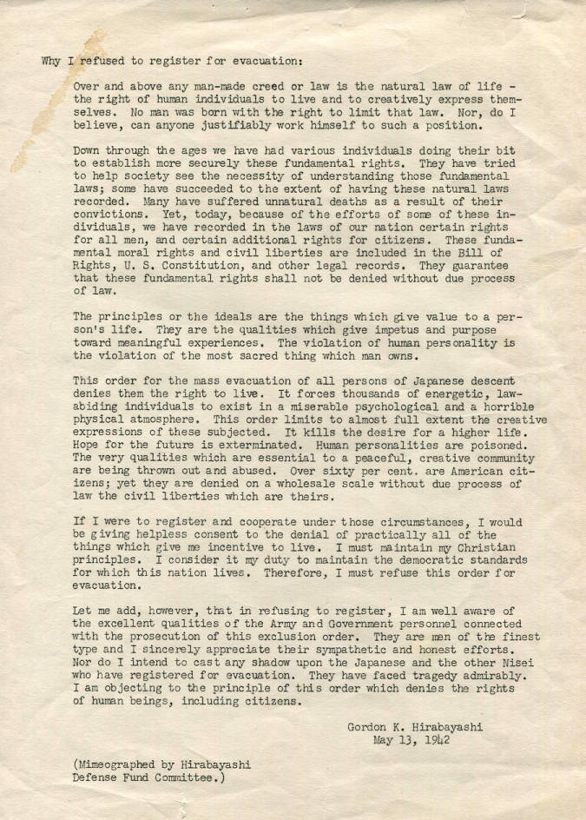
George Hirabayashi intentionally resisted incarceration because he believed it to be unconstitutional, which would later result in the case Hirabayashi v. United States. More here: https://encyclopedia.densho.org/Gordon_Hirabayashi/

Document L: Tule Lake Segregation Center-Newall, California
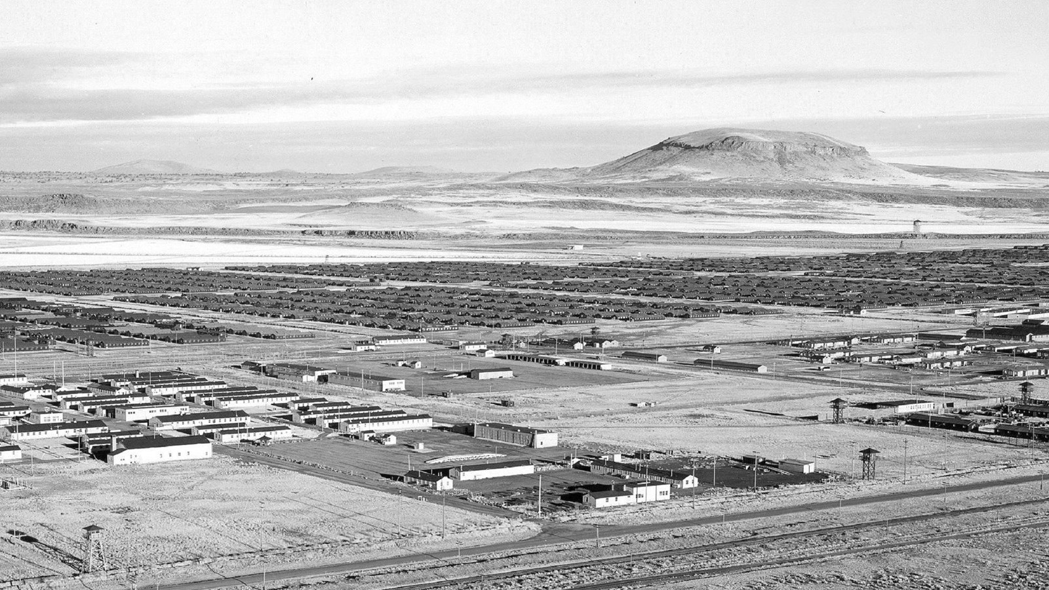
Tule Lake Segregation Center was the largest camp with 18,700 people. Originally created for incarcerees from the Sacramento area, it later house people who answered no-no on questions 27 and 28 of the loyalty questionnaire.

Document M: Teacher Lily Namimoto and her second grade class (1942)
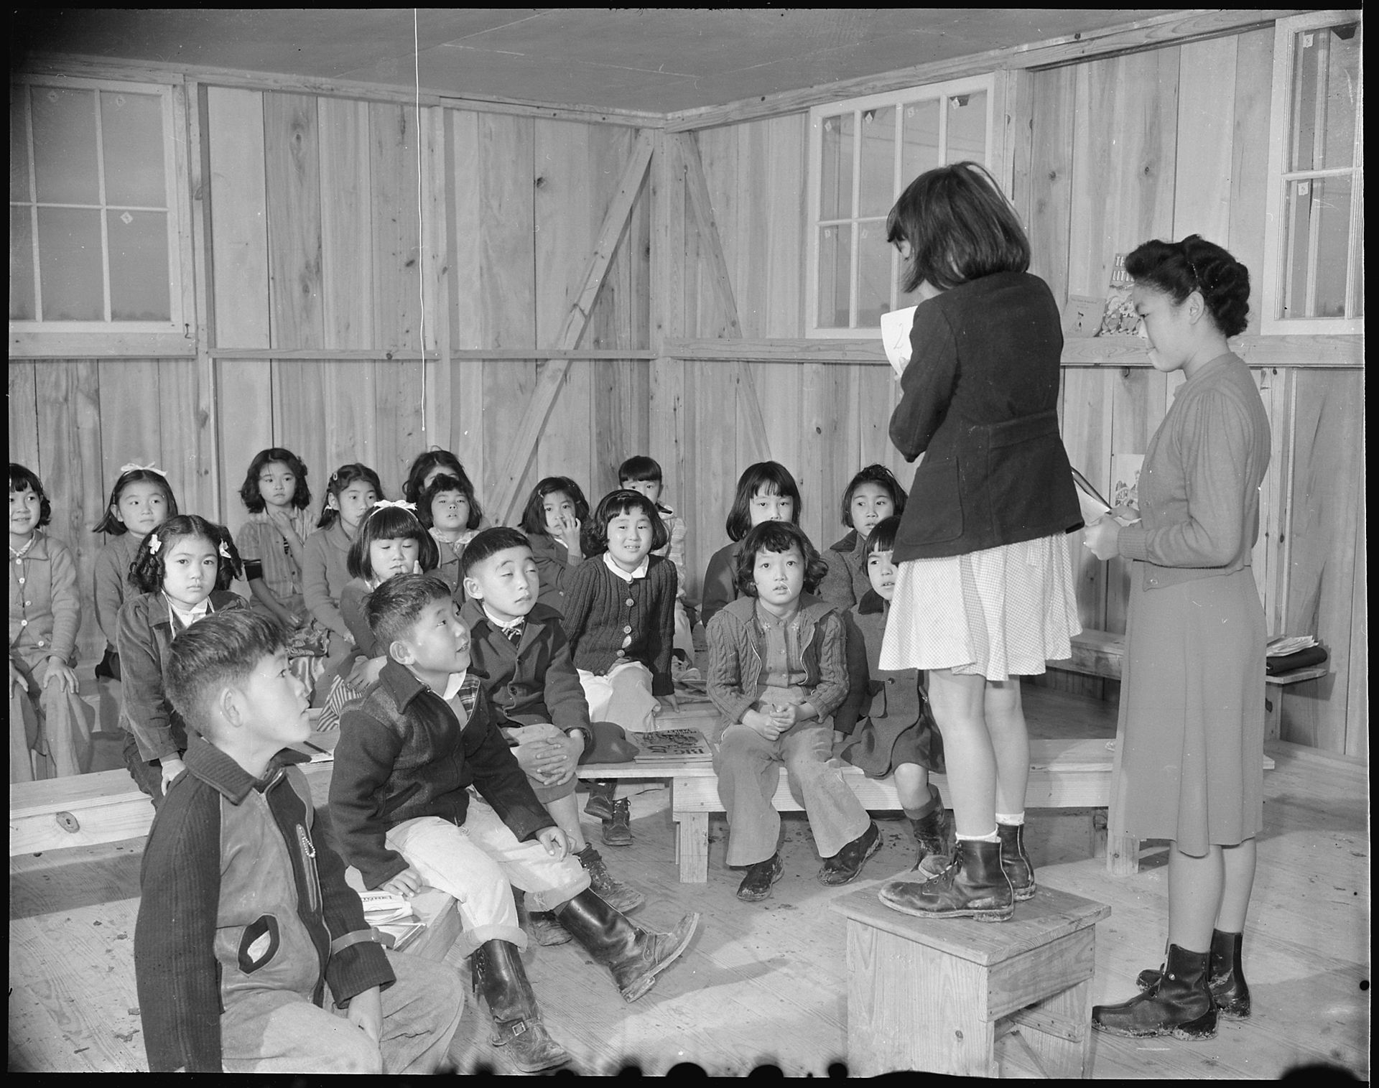

Document N: Judo Class, Rohwer-Arkansas (1942)
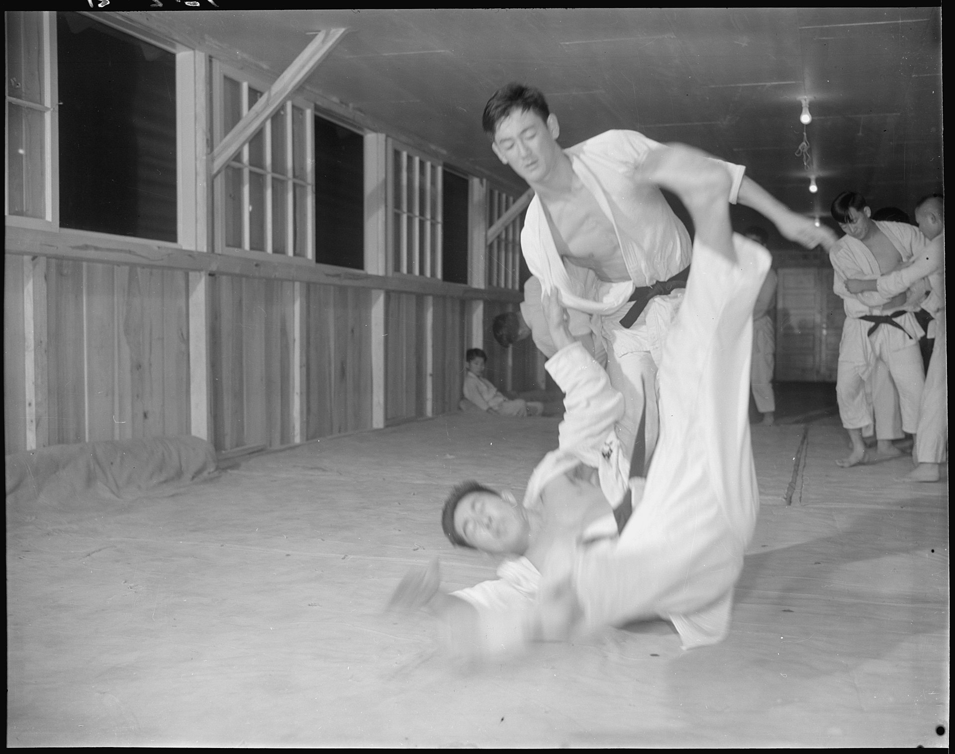

Document O: Patriotism and Protest
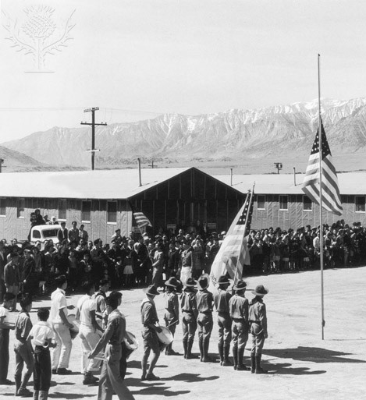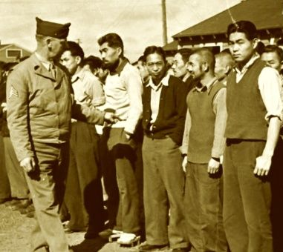
There was division among the Japanese American community around a response to incarceration. Some leaders, such as Japanese American Citizens League executive director Mike Masaoka, should take all measures to prove their loyalty to the U.S. government. As a result, patriotic events were sometimes planned (often captured by wartime government photographers, such as the above left picture at Manzanar). Yet, there were also people who openly protested their incarceration, such as the Manzanar Uprising in 1942, no-nos (people who answer “no” on questions 27 and 28 of the loyalty questionnaire), draft resisters in camp (after the U.S. government began to draft Japanese Americans in 1944) and the Fair Play Committee at Heart Mountain, and the Tule Lake Strike November 1943-January 1944; Above right). See here: See the graphic novel “We Hereby Refuse”: https://resisters.com/we-hereby-refuse/

Document P: Government Newsreel “Japanese Relocation” (1943)

Watch this clip as a class: http://www.archive.org/details/Japanese1943

U.S. government-produced film defending the World War II internment of Japanese American citizens. U.S Office of War.

Document Q: Clip from “Korematsu and Civil Liberties” (2009)

https://www.youtube.com/watch?v=6mr97qyKA2s [00:00-12:45]

A short documentary film produced by Annenberg Media on Korematsu v. United States (1944), where Fred Korematsu challenged the imprisonment of Japanese Americans.

Document R: Baseball game in Manzanar-Inyo County, California (1943)
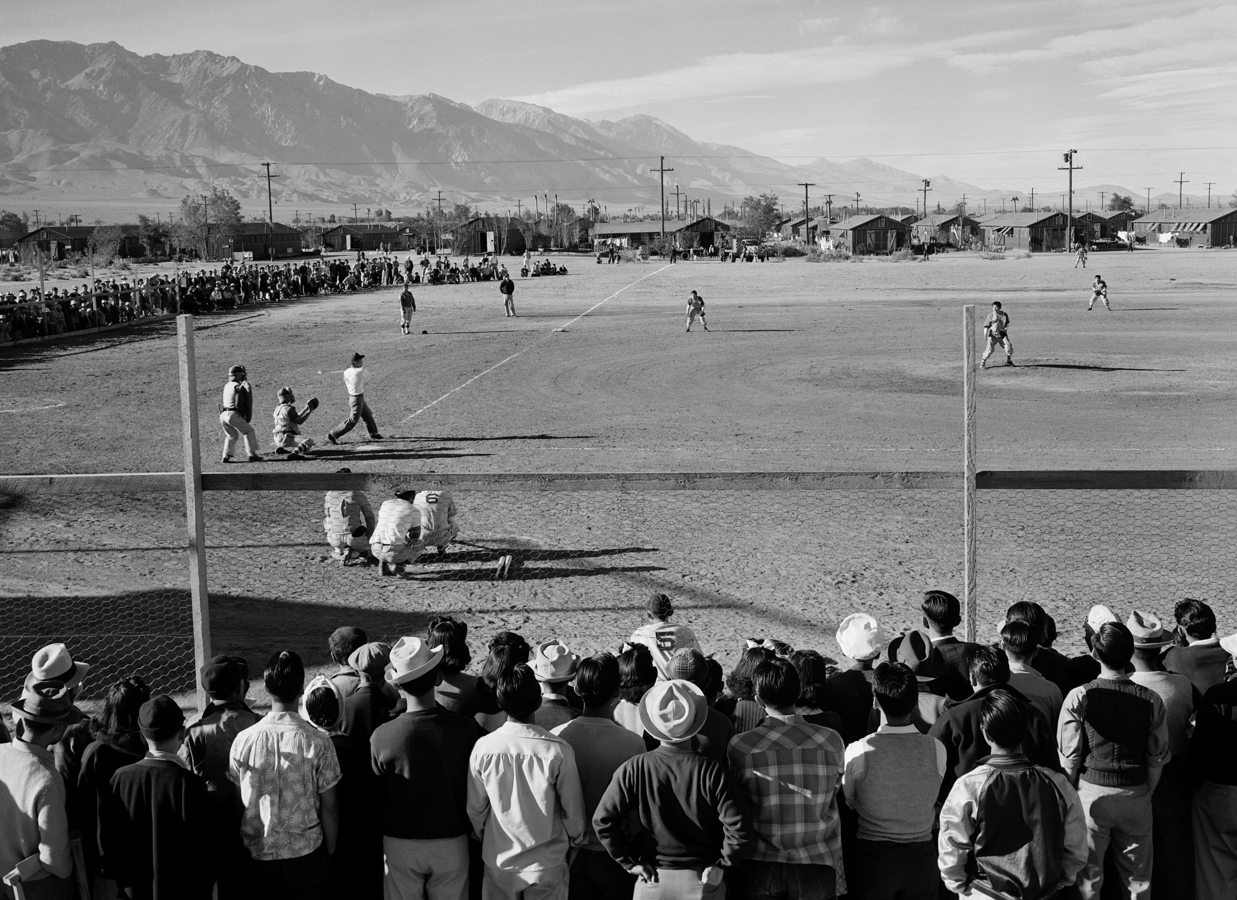

Document S: Camp Art (Circa 1943)
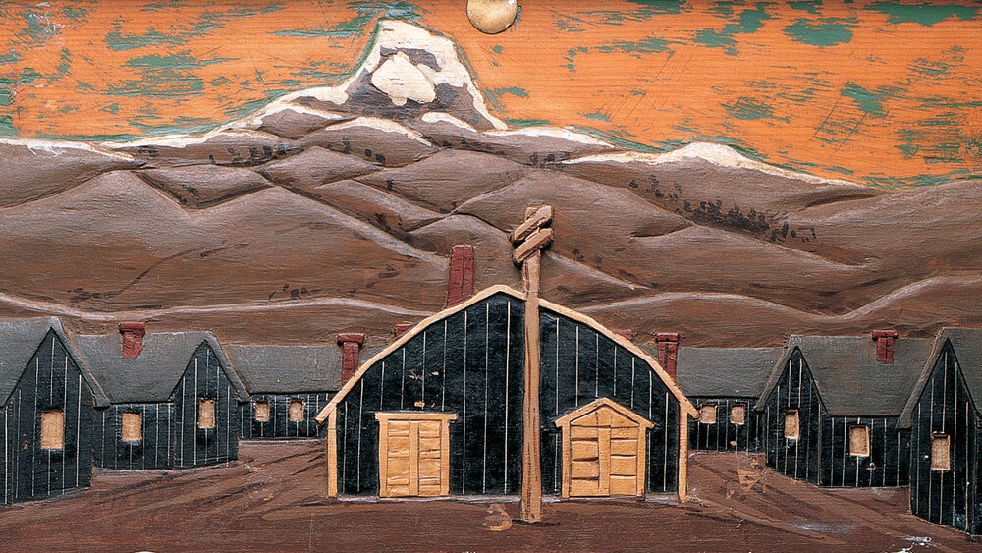
A painted wood carving by an unidentified internee depicts the Heart Mountain Relocation Center in Wyoming. It is showcased in The Art Of Gaman, an exhibit curated by Delphine Hirasuna at the Smithsonian's Renwick Gallery in Washington, D.C.

Document T: The Supreme Court Decision in Korematsu v. United States (1944)
We uphold the exclusion order as of the time it was made and when the petitioner violated it. ... In doing so, we are not unmindful of the hardships imposed by it upon a large group of American citizens. ... But hardships are part of war, and war is an aggregation of hardships. All citizens alike, both in and out of uniform, feel the impact of war in greater or lesser measure. Citizenship has its responsibilities, as well as its privileges, and, in time of war, the burden is always heavier. Compulsory exclusion of large groups of citizens from their homes, except under circumstances of direst emergency and peril, is inconsistent with our basic governmental institutions. But when, under conditions of modern warfare, our shores are threatened by hostile forces, the power to protect must be commensurate with the threatened danger... To cast this case into outlines of racial prejudice, without reference to the real military dangers which were presented, merely confuses the issue. Korematsu was not excluded from the Military Area because of hostility to him or his race. He was excluded because we are at war with the Japanese Empire, because the properly constituted military authorities feared an invasion of our West Coast and felt constrained to take proper security measures, because they decided that the military urgency of the situation demanded that all citizens of Japanese ancestry be segregated from the West Coast temporarily, and, finally, because Congress, reposing its confidence in this time of war in our military leaders -- as inevitably it must -- determined that they should have the power to do just this.

Source: In a controversial ruling, the Court upheld the constitutionality of Executive Order 9066 in the case of Fred Korematsu. The excerpt above is from the Court’s majority opinion written by Chief Justice Hugo Black.

Document U: Densho Interview and Document Repository

Listen to the stories of Japanese Americans who were incarcerated during the war and examine sources from camp: https://ddr.densho.org/

Document V: Interview with Aiko Herzig-Yoshinaga About Life in the Camps

When the Japanese military attacked Pearl Harbor, Aiko Yoshinaga was a senior at Los Angeles High School. “My principal took the Japanese students aside and said, ‘You're not getting your diplomas because your people bombed Pearl Harbor.’ Her family would be eventually sent to Manzanar. There she said, "The only thing that was in the 'apartments' (barracks) when we got there were army metal beds with the springs on it, and a potbellied stove in the middle of the room," Herzig-Yoshinaga says. "That was the only thing. No chest of drawers, no nothing, no curtains on the windows. It was the barest of the bare." She remembers being given a canvas bag and being told to fill it with hay for use as a makeshift mattress. The families eventually created room dividers out of sheets and began making a life in the Manzanar War Relocation Center. Yoshinaga gave birth to her daughter in the camp.

Source: https://www.npr.org/2016/12/07/504602293/at-92-a-japanese-american-reflects-on-the-hardships-of-internment-camps

Document W: Office Memorandum from J. Edgar Hoover (1944)

To: The Attorney General; From: J. Edgar Hoover – Director, Federal Bureau of Investigation; February 7, 1944

There is attached a memorandum relative to Lieutenant General DeWitt’s final report on the Japanese evacuation of the West Coast. Certain statements were made in the report indicating that immediately after the attach on Pearl Harbor there was a possible connection between sinking of United States ships by Japanese submarines and alleged Japanese espionage activity on the West Coast. It was also indicated that there been shore-to-ship signaling, either by radio or lights. at this time. As indicated in the attached memorandum, there is no information in the possession of this Bureau as the result of investigations conducted relative to submarine activities and espionage activities on the West Coast which would indicate that the attacks made on ships or shores in the area immediately after Pearl harbor have been associated with any espionage activities ashore or that there has been any illicit shore-to-ship signaling, either radio or lights.

Source: Memo from J. Edgar Hoover to the Attorney General refuting statements made in DeWitt's Final Report claiming there was espionage activity conducted by Japanese on the West Coast immediately following Pearl Harbor.

Document X: Japanese American Redress Movement
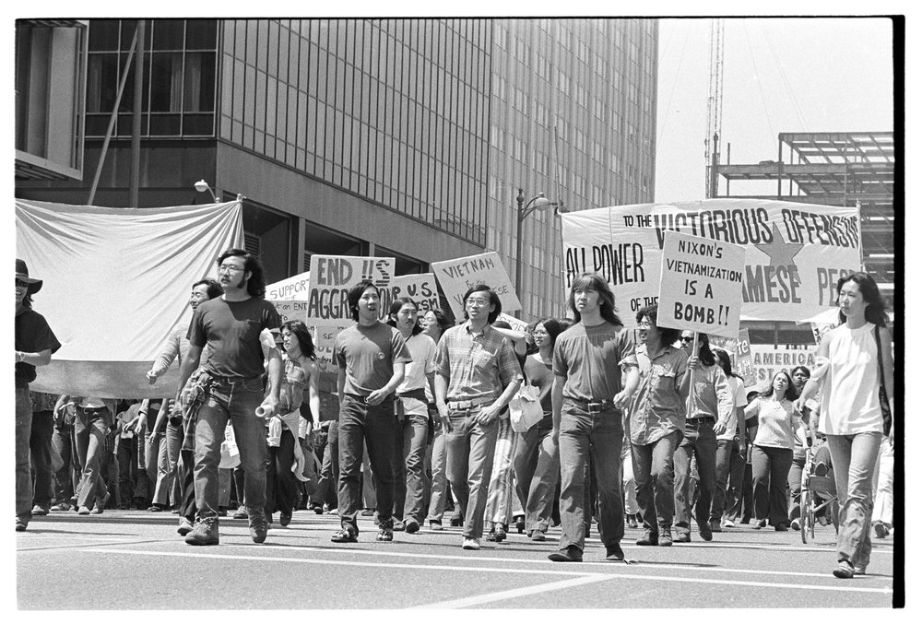
Above: During the 1960s and 1970s, Japanese Americans began to connect the struggle for redress with anti-racist and anti-imperialist movements of the time, which laid the groundwork for government reparations.

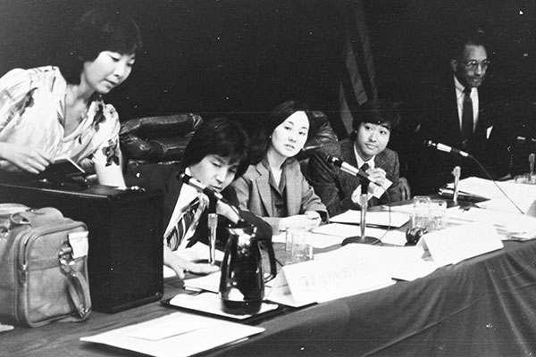
Above: Japanese Americans testifying during the Commission on Wartime Relocation and Internment of Civilians.

Document Y: Signing of the Civil Liberties Act of 1988, which granted reparations for incarcerated Japanese Americans
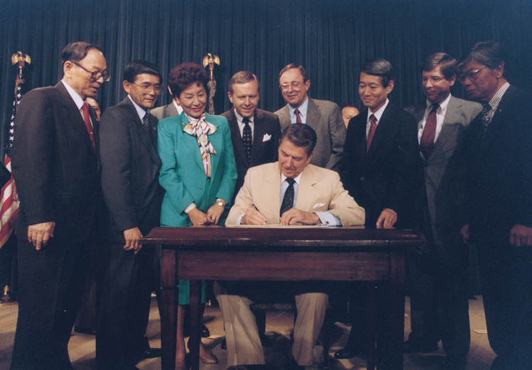
Pictured: Hawaii Sen. Spark Matsunaga, California Rep. Norman Mineta, Hawaii Rep. Pat Saiki, California Sen. Pete Wilson, President Ronald Reagan, Alaska Rep. Don Young, California Rep. Bob Matsui, California Rep. Bill Lowery, and JACL President Harry Kajihara.

Document Z: Tsuru for Solidarity
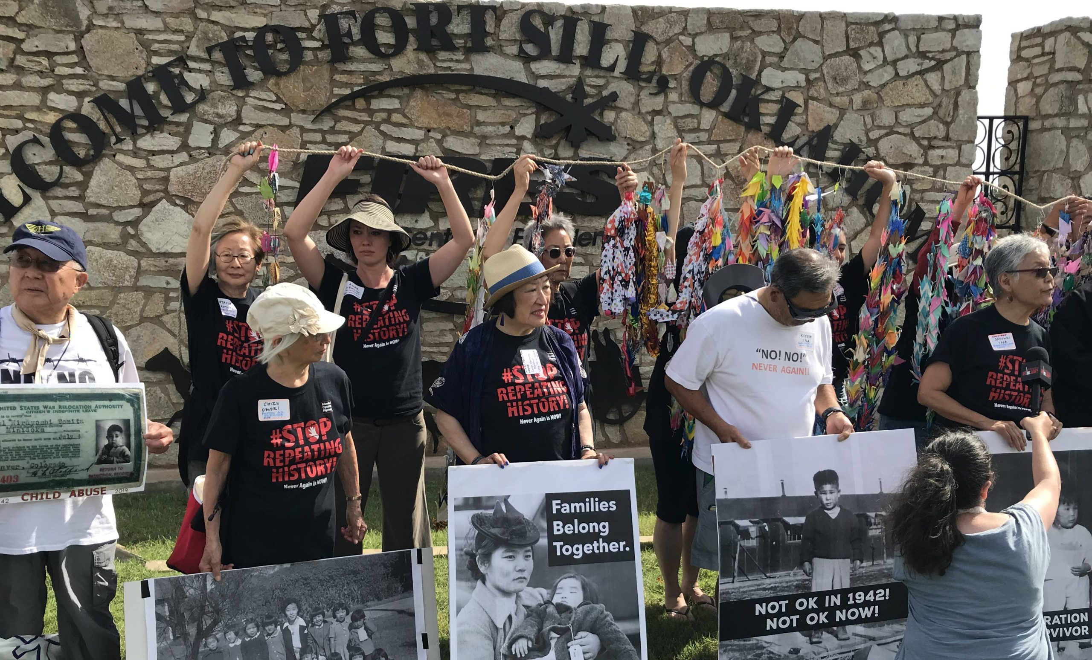
Japanese Americans continue to organize to stop racism against other communities. In 2019, the Tsuru for Solidarity movement formed against migrant detention sites and support migrant family reunification at the U.S.-Mexican border.

